2011 PA Make It With Wool Contest
Somerset County, PA

The 2011 PA Make It With Wool Contest was held on Saturday, October 15, 2011 in Somerset County. There were a total of 24 contestants in the following categories: 9 – Preteen, 6 – Juniors, 2 – Seniors, 5 – Adults, and 2 - Made for Others.
The results are:
Preteens - Libby Bryner, Fayette - 1st, Rebecca Schaefer, Beaver - 2nd, Sadie Knopsnyder, Fayette - 3rd
Juniors - Angela Villanueva, Lebanon - 1st, Stephanie Augustine, Carbon - 2nd
Seniors - Gabrielle Augustine, Carbon - 1st & 2nd Place
Adults - Sharon Donahoe, Bedford -1st, Katherine Augustine, Carbon - 2nd
Made for Others - Tie for 1st Place - Sharon Donahoe and Joan Klein
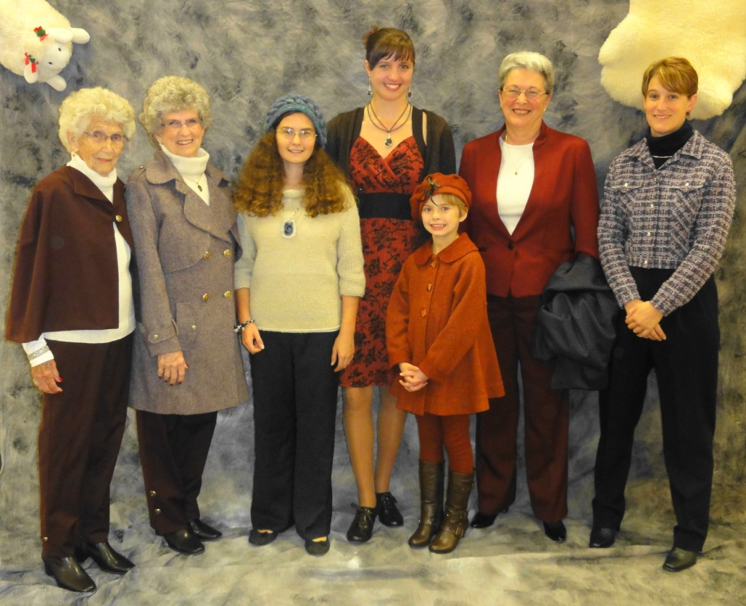
(1st Place Winners: L-R Made for Others by Joan Klein, Joan Klein, Junior Angela Villanueva, Senior Gabrielle Augustine, Preteen Libby Bryner, Adult Sharon Donahoe, and Made for others by Sharon Donahoe)
The first place Junior and Senior contestants as well as the Adult (outfit only) are eligible to compete at the National Make It With Wool Contest to be held in January 2012 in Scottsdale, Arizona. Best of luck to all!

